October STEM
Hurricanes!
Imagine a force that can toss boats around like toys, wash away bridges, and create waves as high as 18 feet. With fierce winds and torrential rains, hurricanes can do all of these things. For centuries people did not know when a hurricane was coming.

Standards

Challenge
Create a house that will survive the storm surge. The house must have sides walls and a roof. The frame and house walls must stay with base or slab during the surge.

Constraints
- House must be at least 4 inches tall
- House does not have to keep water out of the house
- House must survive a 4 cup storm surge

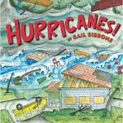
Materials
- Popsicle sticks/tooth picks
- Wall material
- Tape
- Anchor material

Tools
- Scissors
- Rulers
- Flood plain

